Circle Language Spec: Inheritance

Member Addition
The easiest technique for specialization by altering the member set is member addition. Here the concept of class inheritance is displayed:

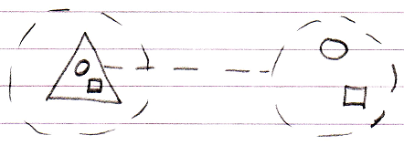

Member addition means adding a member, that was not there in the base, but will be in the derived object:

